

PROJECT DOCUMENTATION

TITLE : AUTOMATING EMPLOYEE DATA

TEAM ID : 69bd2128f58a227701cca08c
Project done by a team of four Members

Team Leader : Lakshmipraja.V
Team Member : Sharmila.T
Team Member : Sowdeeswari.S
Team Member : Suriyaprabha.M

AUTOMATIC EMPLOYEE DATA

Project Statement :
In modern HR and IT environments, manual entry of employee data and repetitive filling of user details on incident forms are major operational bottlenecks. Manual processing leads to data discrepancies, delayed response times, and increased administrative overhead.
This project aims to implement an automated data pipeline using ServiceNow Import Sets and Transform Maps. By automating the bulk import of employee records and utilizing Dot-Walking and Dictionary Overrides, the system ensures data integrity, streamlines the incident creation process, and optimizes organizational efficiency.
Project Objectives :
Automate Data Entry: Eliminate manual record creation through bulk Excel imports.
Streamline Mapping: Use Transform Maps to ensure external data matches ServiceNow fields accurately.
Enhance UI Efficiency: Implement Dot-Walking to auto-populate user metadata on forms.

Custom Configuration: Use Dictionary Overrides to set table-specific priorities without affecting the global Task table.
Data Integrity: Ensure consistent manager-employee relationships across the platform

Skills Required :
Technical Skills
ServiceNow Administration: Import Sets, Transform Maps, and Dictionary Management.
Data Management: Excel/CSV data structuring and cleaning.
Platform Configuration: Form Design and Reference Field
navigation .
Analytical Skills:
Data Mapping: Aligning source fields to target table attributes.
Logic Design: Understanding table inheritance and overrides.
Process Optimization: Identifying manual steps for automation.
Tools & Software:
ServiceNow Platform (Rome/San Diego/Tokyo or later versions)
Microsoft Excel / Google Sheets
ServiceNow Studio (Optional)

Phase 1: Spreadsheet Data Preparation
- The foundation of the automation is a structured data source
○ Open Google Sheets or Excel.
- Create a header row with the following fields: Name, Email, Department, Manager, and Manager Email.
- Fill in the employee records accordingly.

- Download the file as employee_data.xlsx.
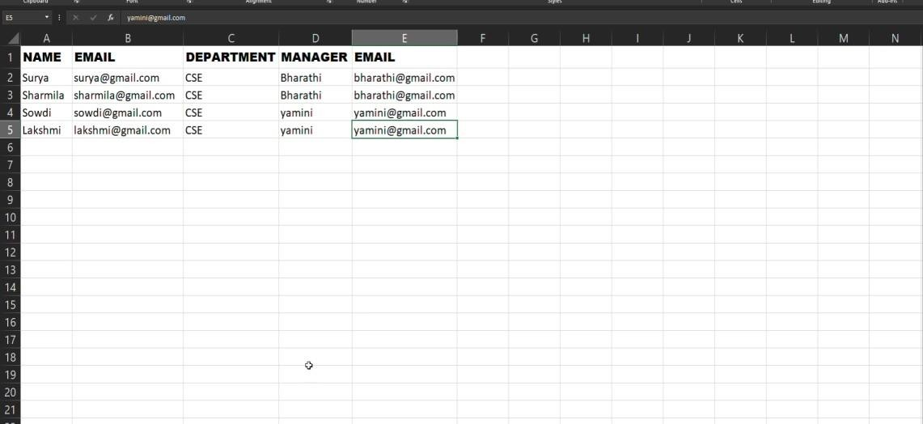

Phase 2: Loading Data to Import Sets
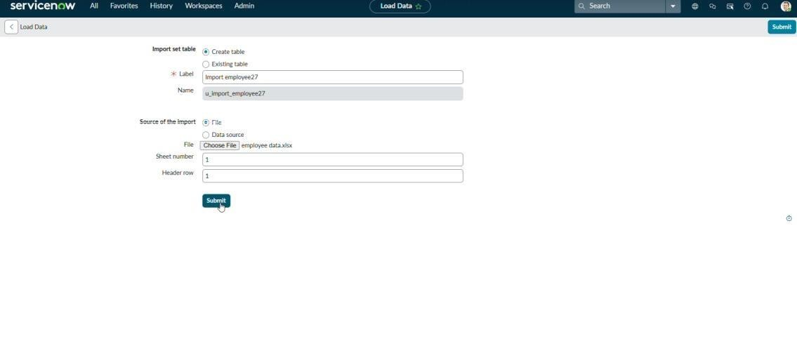
- This phase moves the raw data into the ServiceNow staging environment.
- Navigate to All > System Import Sets > Load Data.
- Select Create Table.
- Label: Input Employee.
- Source: File.
- Choose the employee_data.xlsx file.
- Click Submit to load the data into the staging table.

Phase 3: Creating the Transform Map
- Transform Maps bridge the gap between your Excel data
and the ServiceNow User table.
- Navigate to System Import Sets > Create Transform Map.
- Name: Employee Data Transform.
- Source Table: u_input_employee.
- Target Table: User [sys_user].
- Click Save.

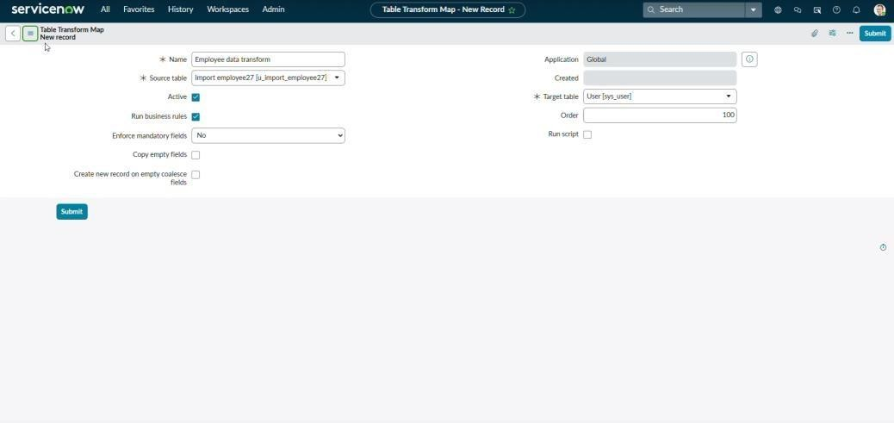

- Under Related Links, click Auto Map Matching Fields.
- For the Manager field, use the Mapping Assistant to
ensure the reference is linked correctly.
- Click Transform to move the records into the live User table.

Phase 4: Enhancing Incident Forms (Dot-Walking)
- To allow agents to see data without clicking through
records, we utilize Dot-Walking.
- Open any Incident form.
- Right-click the Header > Configure > Form Layout.
- In the Available list, find the Caller or Assigned to field.
- Click the Expand ( + ) icon  To access related fields.

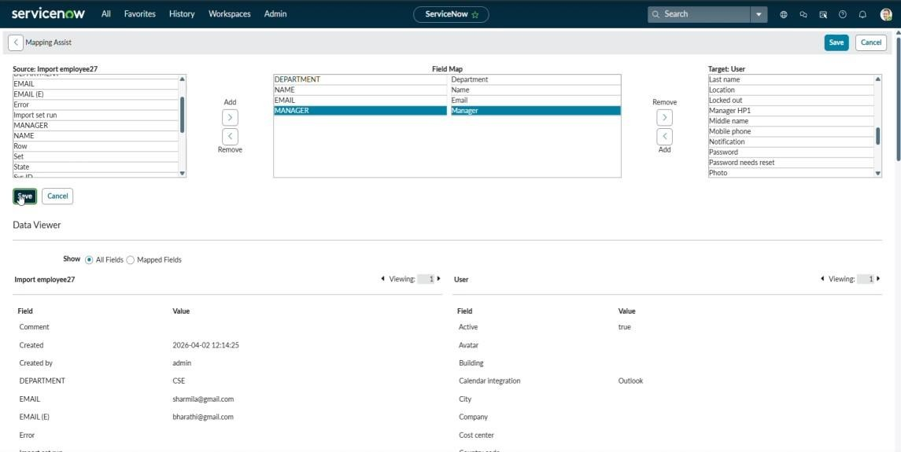
- Select Department, Email, and Manager.
- Move them to the Selected list and click Save.
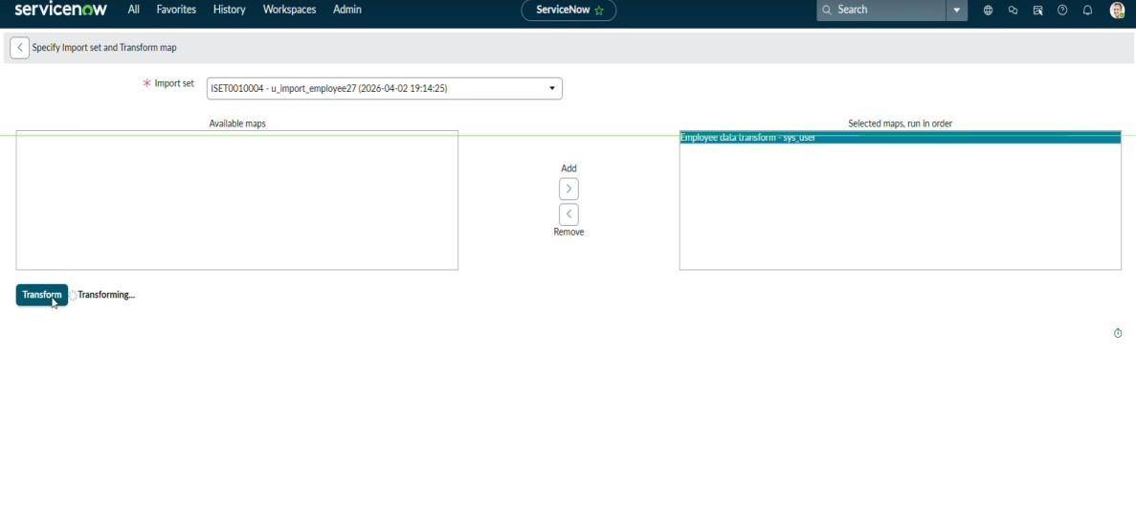
- Result: Selecting a user now automatically displays their department and email on the form.

Phase 5: Implementing Dictionary Overrides
- This ensures Incident tickets have a custom priority default.
- Search for Dictionary in the navigation bar.
- Find the entry for the Priority field on the Task table.
- Scroll down to the Dictionary Overrides related list and click New.
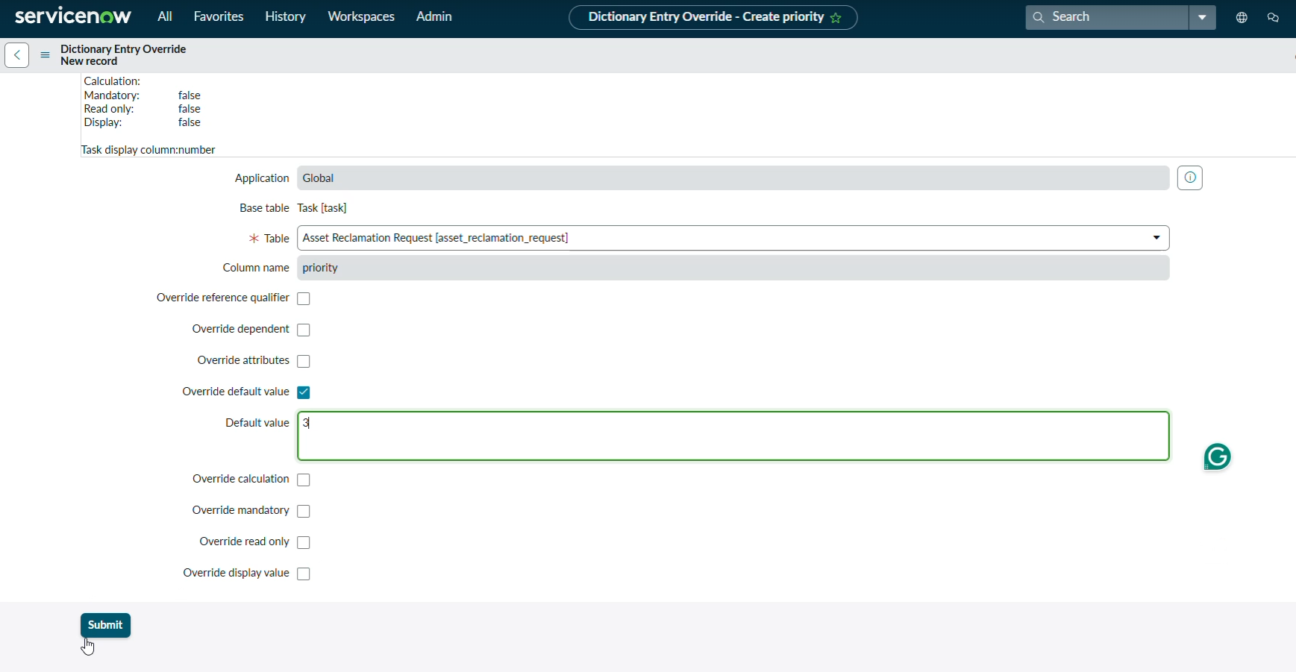
- Table: Incident.
- Check the box for Override default value.
- Default value: 3 (Moderate).

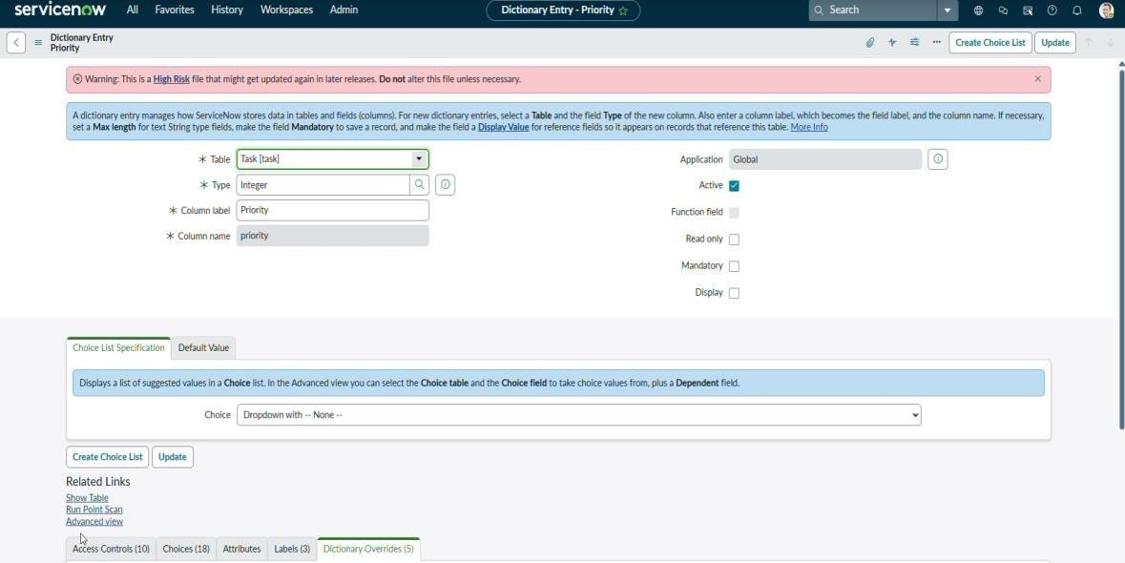
- Click Submit.

Conclusion
The "Automatic Employee Data" project successfully transforms a manual HR task into a seamless automated process. By integrating bulk imports with UI enhancements like Dot-Walking, we have reduced the time required for incident logging and ensured that the ServiceNow environment remains a reliable "Single Source of Truth" for employee information.

